**NLP Chatbot Development using Dialogflow**

**Design Document**

**Version 1.0**



**Group Id: F24PROJECTE6E8C**

**Supervisor Name: Abdullah Qamar**

**Revision History**

|  |  |  |  |
| --- | --- | --- | --- |
| **Date (dd/mm/yyyy)** | **Version** | **Description** | **Author** |
| 17/1/2025 | 1.0 | In this project, we introduce our project and explain how we creating it. We also describe the scope of this project and explain its development on the basis of functional and nonfunctional requirements related to the project.  We can also explain this project document with the help of a use case diagram which can help understand how users can act and work on this software. usage scenario Adopted methodology and work plan are also used in this document to explain the project of this NLP chatbot | BC200403791  BC200407809 |
|  |  |  |  |
|  |  |  |  |
|  |  |  |  |

**Table of Contents**

1. Introduction of Design Document
2. Entity Relationship Diagram (ERD)
3. Sequence Diagrams
4. Architecture Design Diagram
5. Class Diagram
6. Database Design
7. Interface Design
8. Test Cases

**Introduction to Design Document:**   
This document contain all the structure and outline for development of (Natural Language Processing) NLP chatbot for a restaurant, in which three actors are involve (Admin, Restaurant Staff and Customer). The main aim is to understand how the communication between these actors can be presented and used in the design of chatbot, permitting the chatbot to work for its anticipated purpose efficiently.

1. **Admin:**The person responsible for managing all the operations of the restaurant. It will be the duty of admin to provide all necessary information, such as menu, reservation, special offers and operational changes.  
   **Duties:** The duties of Admin include;   
   Update the amendments in necessary information.

Monitoring of chatbot performance and view from customer and staff.   
 Training of chatbot with different FAQ’s.

1. **Restaurant Staff:** Restaurant staff includes waiters, Servers and Kitchen Staff. They are going to interact with chatbot using two ways; from back-end part to communicate with customers in indirect way and retrieve the order, and as one who fulfil the order the order that is assist by chatbot.  
   **Duties:**  Order handling placed via chatbot.   
    Delivering feedback on the effectiveness of chatbot in order management.
2. **Customer:**

End users of the system are the customers, they will communicate with chatbot to perform actions, such as reservation, placing order and asking about the menu of restaurant.  
**Duties:**To communicate with the chatbot in natural language.  
Delivering feedback on the effectiveness of chatbot.

**Benefits and Purpose of Design Document of NLP Chatbot of Restaurant:**  
In the phase of design document while development of NLP chatbot for a restaurant helps to describe the objectives, functionality and technical requirements of chatbot. The purpose of design document is to plan, how chatbot will communicate with customers and incorporate with the system of restaurant.

Benefits of design document include;

1. **Direction of Project:**   
   It group general understanding between shareholders on the aims and features of chatbot.
2. **Effective Development:**It offers an organized method to make sure even workflows, interphase design and error management.
3. **Even Incorporation:**It ensures chatbot performs well according to the system of restaurant, such as order taking, reservation and payment processing.
4. **Improvement of user’s experience:**   
   It plans how chatbot will communicates with the customer and it will ensure that the conversation is easy to understand.

1. **Entity Relationship Diagram (ERD) (To be developed using Microsoft Visio or any other drawing software of your choice)**

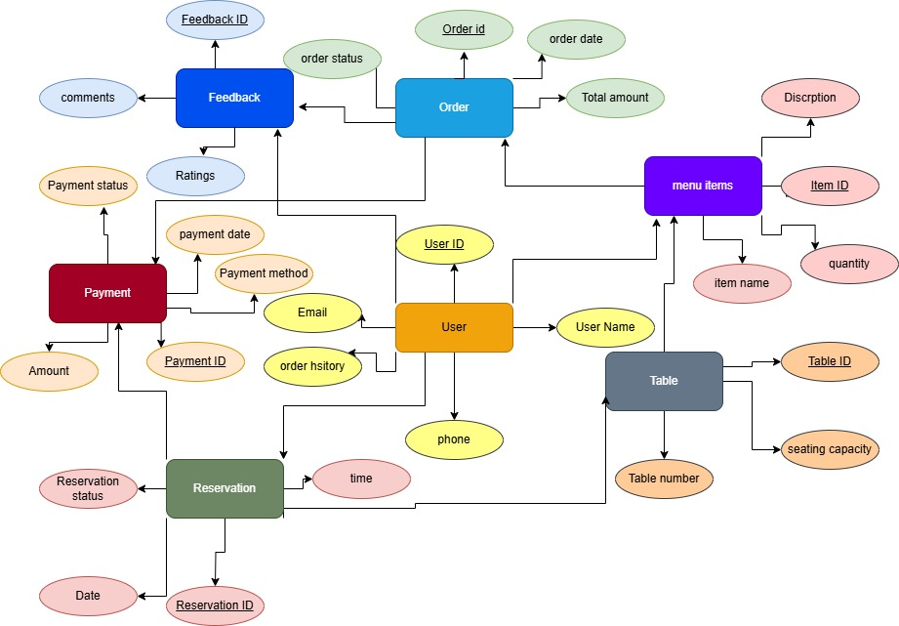

1. Sequence Diagrams (To be developed using Rational Rose or any other drawing software of your choice)

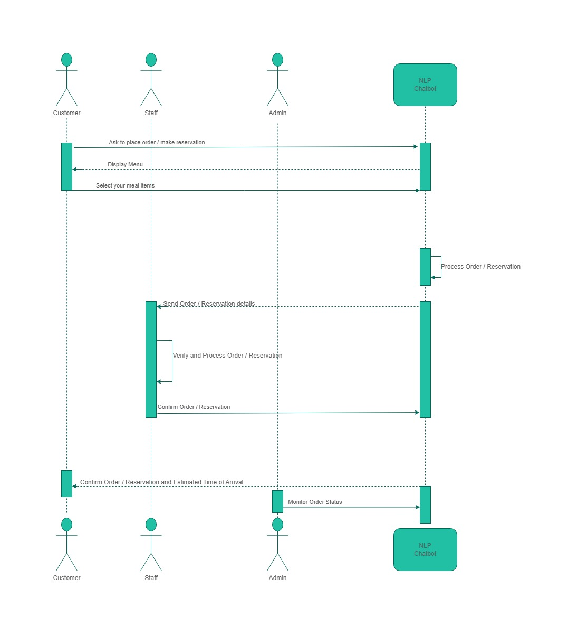

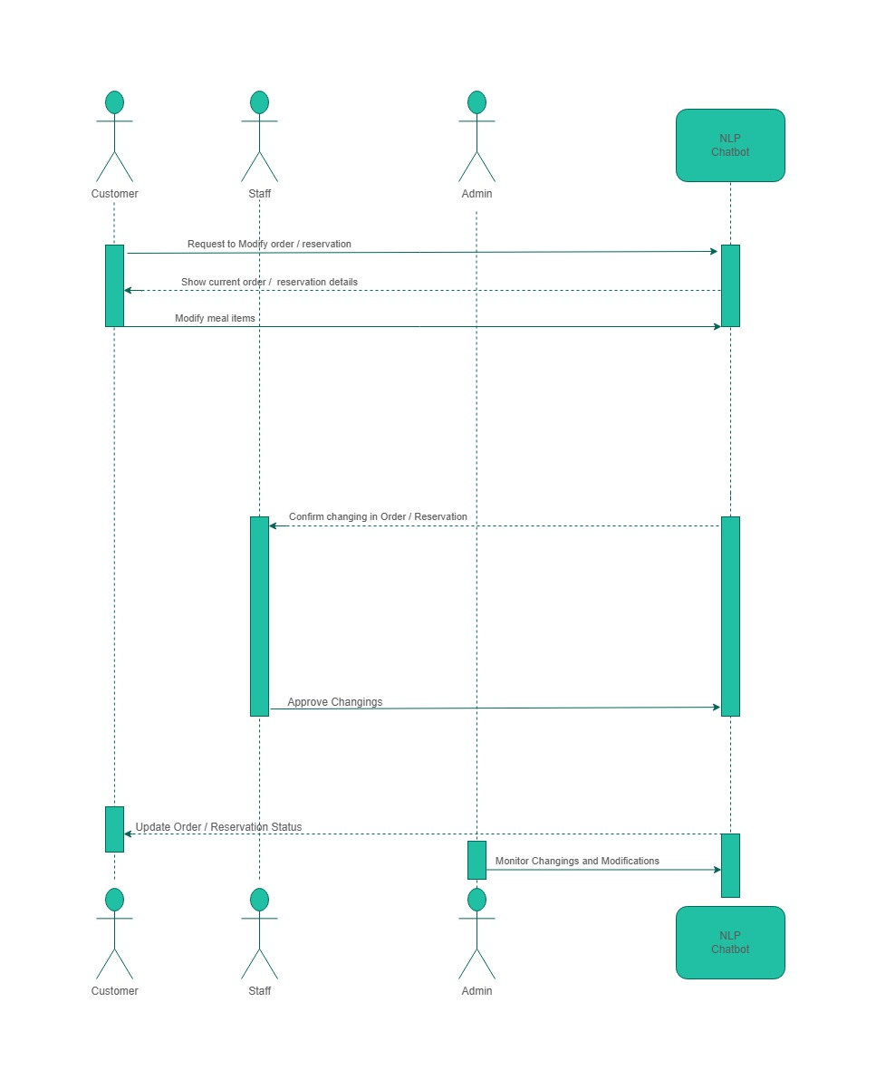

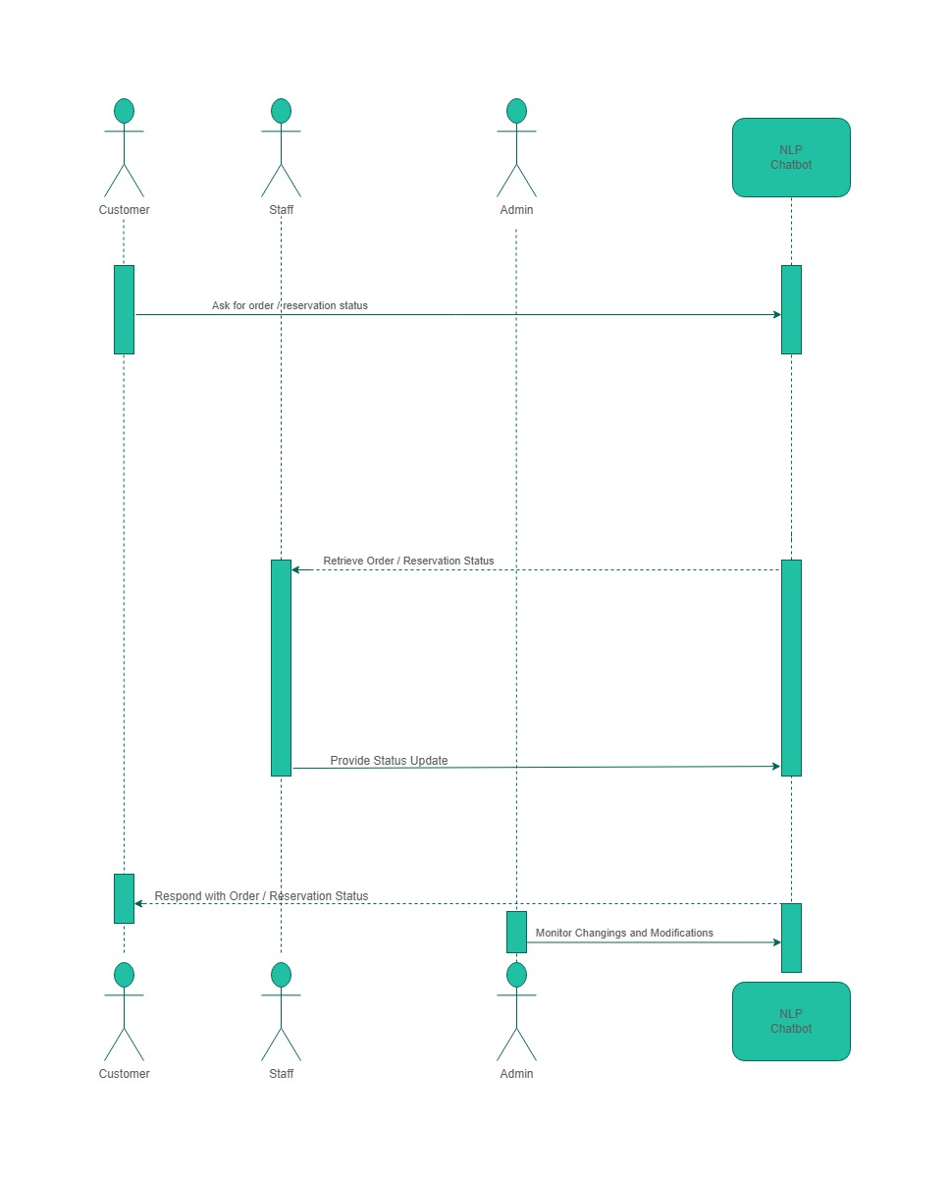

1. Architecture Design Diagram

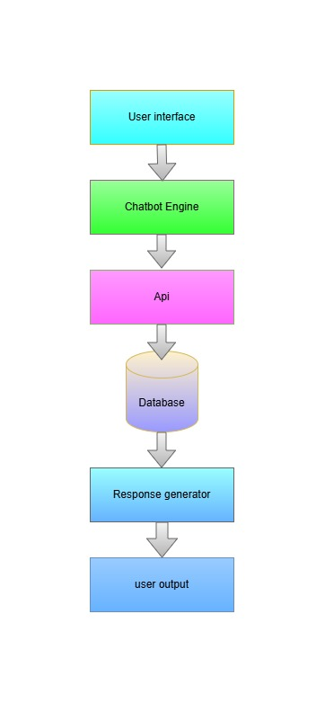

1. Class Diagram

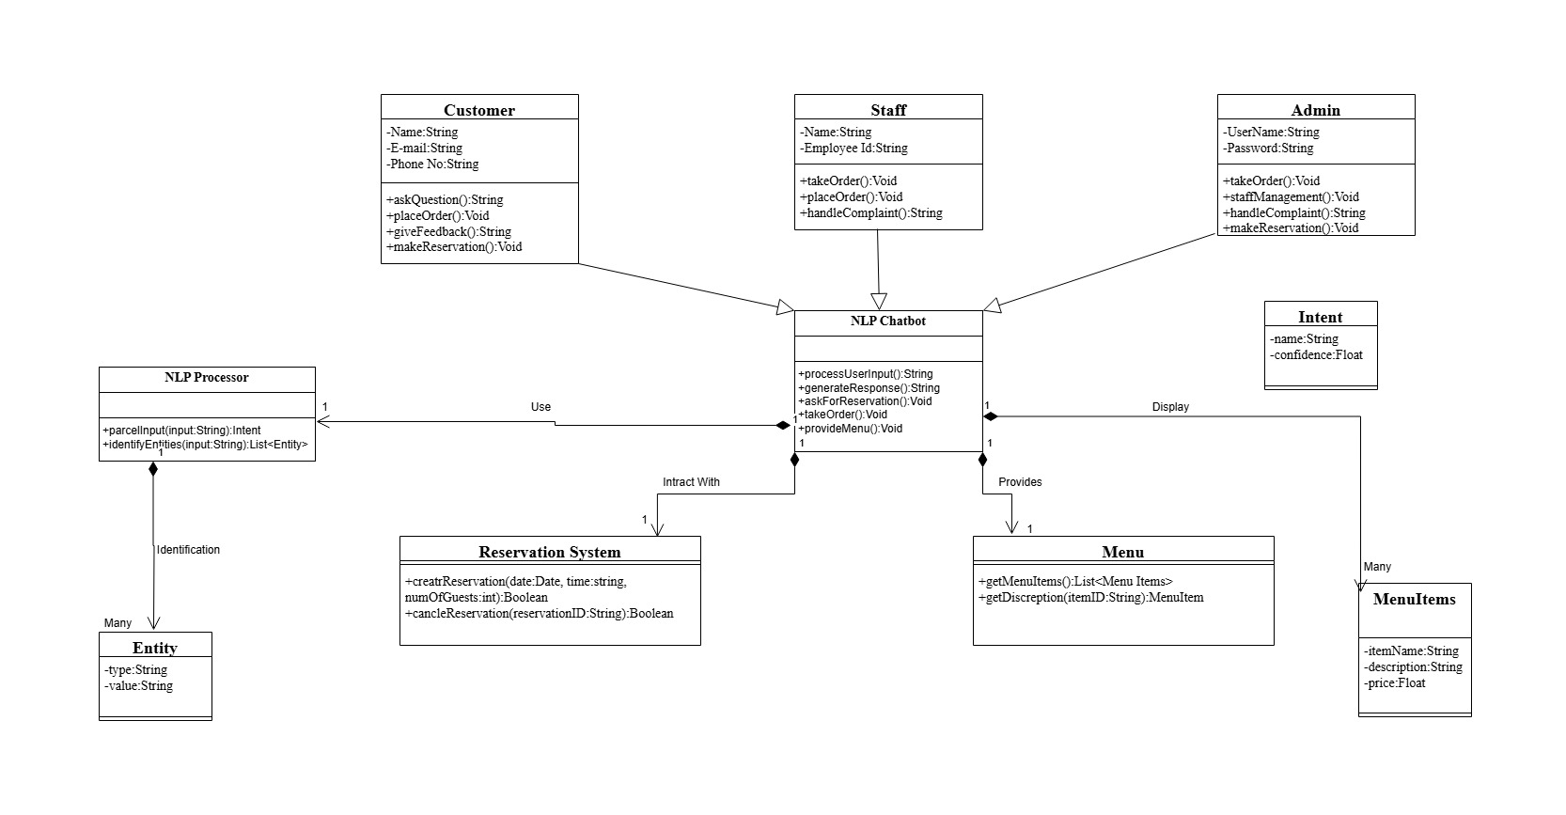

1. Database Design

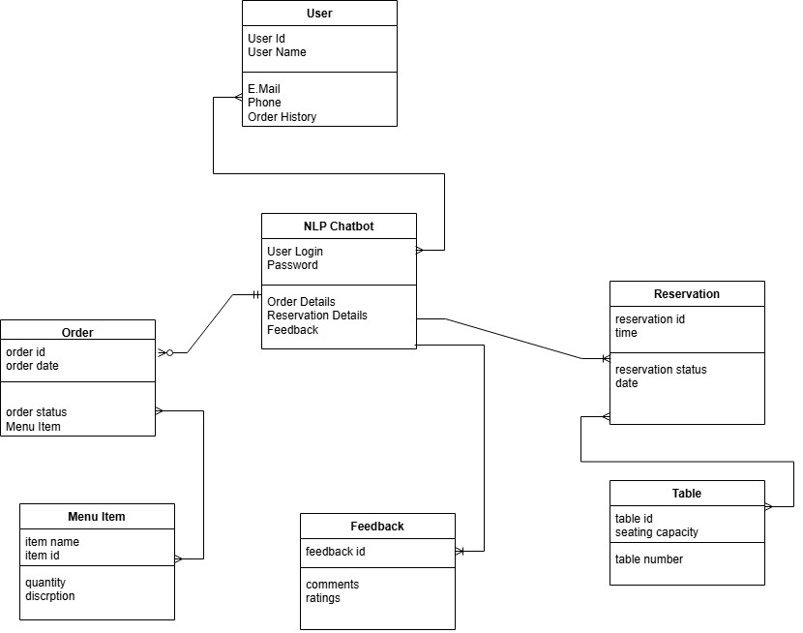

1. Interface Design

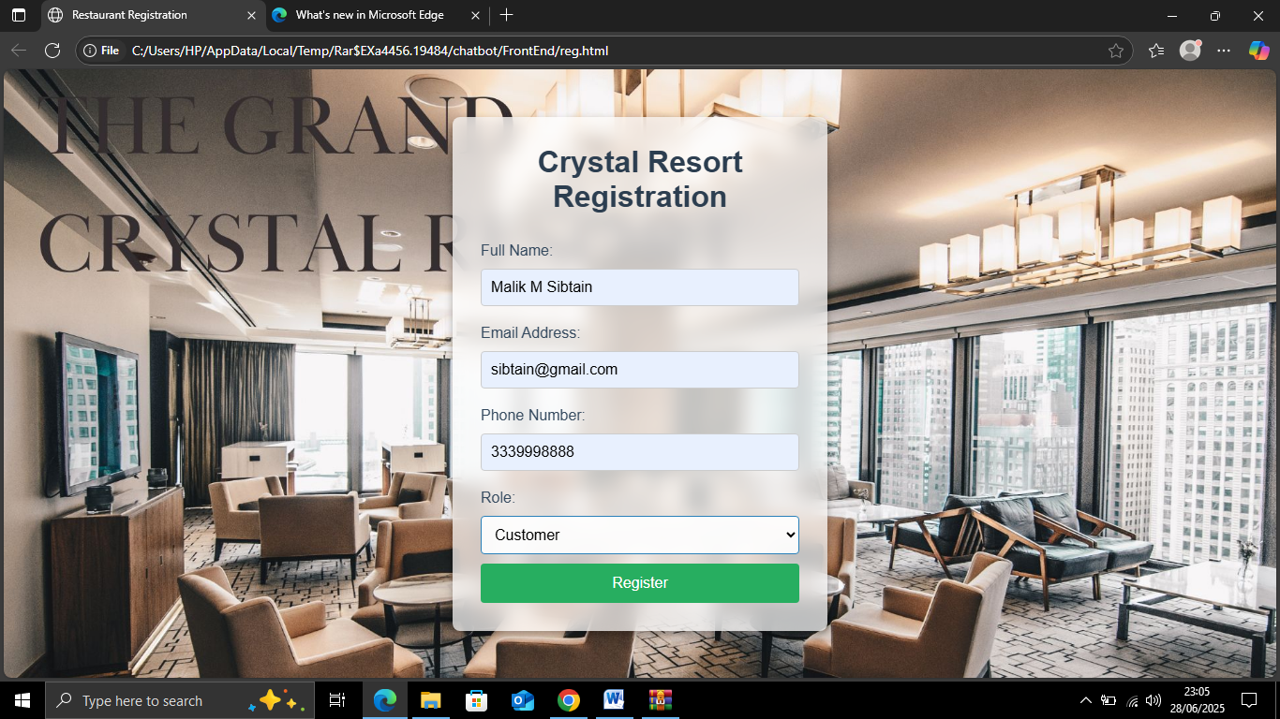

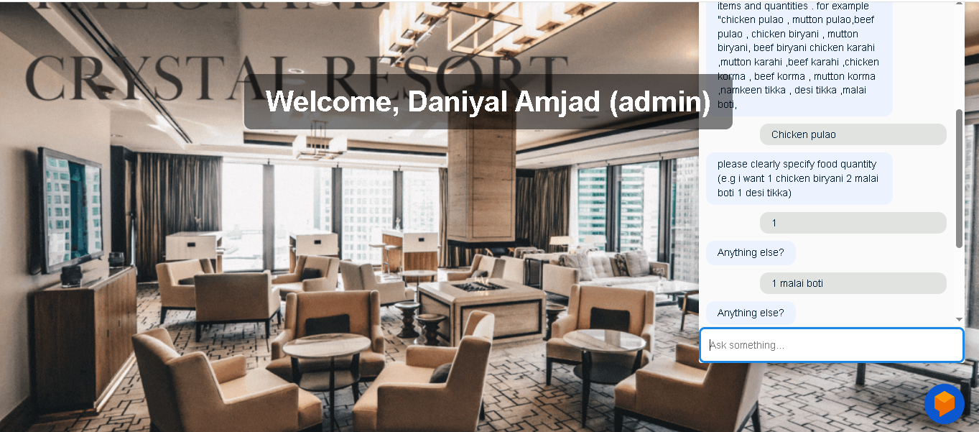

1. Test Cases

**Test Case Table for "Order" Use Case**

| **Test Case ID** | **TC001** |
| --- | --- |
| **Description** | Customer places an order through the NLP chatbot |
| **Input** | "I'd like to order a Margherita pizza with extra cheese and a cola." |
| **Expected Output** | The chatbot processes the order, confirms it, and asks for payment details. After payment, it confirms the order and provides an estimated delivery time. |
| **Pass/Fail** | Pass |
| **Tested By** | bc200407809, bc200403791 |

### ****Test Case Table for "Reservation" Use Case****

| **Test Case ID** | **TC002** |
| --- | --- |
|  |  |
| **Description** | Customer makes a reservation for a table through the NLP chatbot |
|  |  |
| **Input** | "I need a table for two at 7 PM tomorrow." |
| **Expected Output** | The chatbot confirms the reservation details (time, number of people), asks for name and contact number, and then confirms the reservation successfully. |
| **Pass/Fail** | Pass |
| **Tested By** | bc200407809, bc200403791 |

### ****Test Case Table for "NLP Chatbot (General Interaction)" Use Case****

| **Test Case ID** | **TC003** |
| --- | --- |
| **Description** | User interacts with the chatbot to get restaurant information. |
| **Input** | "What time do you open?" or "Do you have vegan options?" |
| **Expected Output** | The chatbot provides relevant and accurate information about restaurant hours or menu options, depending on the query. |
| **Pass/Fail** | Pass |
| **Tested By** | bc200407809, bc200403791 |

### ****Test Case Table for "Feedback" Use Case****

| **Test Case ID** | **TC004** |
| --- | --- |
| **Description** | Customer leaves feedback for the restaurant through the NLP chatbot |
| **Input** | "The food was great, but the service was a little slow." |
| **Expected Output** | The chatbot processes the feedback, categorizes it, and thanks the user for their feedback. |
| **Pass/Fail** | Pass |
|  |  |
| **Tested By** | bc200407809, bc200403791 |

|  |
| --- |
|  |